Psychological Skills Training: Stress Management Skills
written by Dr. Christine Lottes

Athletes’ negative stress levels can severely impact their performances. Continuing our Psychological Skills Training series in pelinks4u, today’s article provides a script for the coach, and, 2 reproducible handouts (one a script for the coach plus a handout for athletes) as we look at how athletes can successfully manage their responses to stressors.

Coach’s Script for: Stress Management Skills

Bring to practice: coach’s script, a copy of the athlete’s handout for each athlete (follows the coach’s script), pencils or pens, chalk

Stress Management

Review:
- Physical and mental energy that fuels your athletic performance is called you’re arousal level.
- It is important how your mind interprets what is going on around you.
- Athletes have different optimal energy zones.
- If you are not in your zone, you can do rapid relaxation to lower arousal or energization to increase arousal.

Today: Stress Management
- Athletes have to deal with stress if they’re going to reach their potential and achieve their competitive goals.
- The problem with stress is that it can get in the way of playing well, it can destroy self-confidence, it can cause conflict and hurt teamwork.
- Why do we feel stress?
- Stress is an imbalance between what we perceive is being demanded of us- Competitive demand- and what we perceive our capabilities are for meeting those demands- personal control….. especially in situations in which success is important.
- Think about time in sport when there was what you perceived as a “big game.” If you were confident that you were ready for it, you saw the big game as a challenge. But if you didn’t think you had the resources to play this opponent then you saw the big game as a threat and were stressed and then may not have played as well….. may not have coped as well with this situation. (Tell a story specific to your sport. Ex. assigning an athlete to defend against a top scorer.).
- What you believe about the stress determines whether uncertain competitive situations are viewed positively as a challenge or negatively as a threat.
- Remember our self-talk session (reader- refer to pelinks4u March 2012)? When an event happens to you, you have beliefs about the situation- how you interpret what has happened. This interpretation of the situation determines your emotions and behavior to a much greater extent than does the situation itself.
- Example: The official misses a call that is obvious to you. Depending what you say to yourself right then will determine how quickly you become an effective player in the game for the team. “She should have called that….. we could lose the game because of that…. he’s favoring the other team……” or “Play”…..
- Self-talk is one of the mental tools we’ve been learning that we can use as a coping strategy to manage stress. The other tools are imagery and relaxation.

List two competitive sport situations that have caused you to become stressed. These situations can be from any competition (off-season, last season, etc.). | Write which is the least stressful which is the most  stressful
Not doing my running this summer so that when we had our first competition my lungs felt like they were going to explode and my legs weighed a ton and I couldn’t last. | Least

- Counterarguments deal directly with negative, unproductive or irrational thoughts.

Take the least stressful situation from the last exercise and complete the following:
Negative Thought that contributed to my stress…….. | Counterarguments for the negative thought. If you need to, see “Purposes & Thoughts for Smart-Talk Scripts” (March Self-Talk article)
I’ll never get in shape enough to play well and I’ve let the team and coach and everyone down and they’re probably mad at me. | I’ll concentrate on doing my best right now as I can’t control what’s past.
 | I will get in shape by working hard.
Coping Response:
- Inhale deeply while repeating a counterargument.
- Repeat the transition word “so” and pause briefly
- Repeat your physical relaxation cue word (see relaxation and energization article in December 2011 pelinks4u) as you exhale deliberately.
Example: “I’ll concentrate on doing my best right now as I can’t control what’s past, so, relax.”

Cue Words:
- Can also be used to quiet mind of intruding thoughts. Ex. the word “ball” can be repeated or the word “focus” is useful in many situations.

Summary
- Whenever possible work to reduce or eliminate sources of stress that you can control: get enough sleep, healthy nutrition, hydrate sufficiently and manage your time effectively (set goals, prioritize what to do first, eliminate time wasters).
- If the stressor can’t be changed or you lack the capability to meet competitive demands, modify how you view the situation in order to manage your emotions.
- What you believe about the stress determines whether uncertain competitive situations are viewed positively as a challenge or negatively as a threat.
- View stress as a surmountable challenge.
- Self-talk (counterarguments), imagery and relaxation (deep breathing and cue words) can be used to manage stress.
- Focus on what you can control: your thoughts and your actions.
- During the season we will be continuing to work out mentally as part of our practices and games.

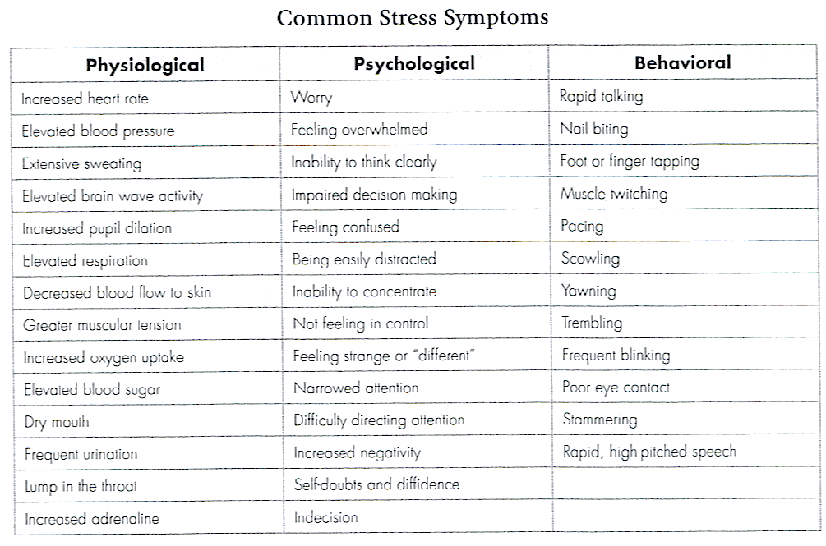
Table 11.3 pg. 180 Sport Psychology for Coaches (2008) by Drs. Damon Burton and Thomas Raedeke, Human Kinetics, Champaign, IL.

Upcoming February and June/July articles on Mental Training…….
In the February and June/July editions of pelinks4u we will be looking at some practice-ready drills coaches can use with their athletes in order to train them in the Psychological Skills presented by Christine over the past year.

